

SCHOOL OF ENGINEERING AND NATURAL SCIENCES

Department of Biomedical Engineering

YTU: Biomechatronics Research Lab Internship Report

Student Name : Rabia GÜL

Student ID : 62150005

Email : rgul@st.medipol.edu.tr

Student’s Advisor :

Date : 01.07.2020 – 28.07.2020

# Overall Description of the Activities/Projects Involved

The internship was completed in YTU: Biomechatronics Research Lab. This Research Laboratory includes mechanism, electronics, mechanical and biological sensors in order to therapy and augmentation of human body. The research group which are involved in the laboratory focus on rehabilitation robots, biomechatronics system design, biological signal processing, artificial intelligence, and industrial automation. Also, they aim to develop intelligent technologies in order to improve and support human-life quality for patients.

During the internship in the YTU: Biomechatronics Research Lab, different areas were investigated as the robots which are design to help disabled people to eat such as The Assistive Dexterous Arm (ADA), My Spoon, iEAT Robot, The Winsford feeder, Obi Feeding Robot, Handy1, Neater Eater, Meal Buddy and The Mealtime Partner Dining System (Mealtime Partners). Remote controlled assistive service robots, their functions and working principles were examined. Besides, robot-assisted surgery was investigated and the working principles of the Da Vinci system which is the best example of the robotic surgery was observed. It can be summarized as performing some surgeries through small holes.

Afterwards, a literature review about the artificial intelligence applications which have significant role in the field of health was completed. Biomechatronic systems developed in the field of physical medicine and rehabilitation and especially artificial intelligence used for the control of these systems were examined. A research study was conducted on the investigation of biomedical equipments that are used in both diagnosis and treatment in the clinic.

# About the Company

Biomechatronics research lab was set by Dr. Akdogan in 2010. Actually, the beginning of your research work in the lab goes back to 2003. At the present time, we have more than five research projects with 2 researchers, 6 graduate and 2 undergraduate students.

Biomechatronics is an interdisciplinary science which aims to realize a computer controlled system including a mechanism, electronics, mechanical and biological sensors in order to therapy and augmentation of human body. Biomechatronics includes the aspects of biology, mechanics, and electronics.

In other words, the main research focus of biomechatronics is to develop intelligent technologies in order to improve and support human-life quality for patients.

A biomechatronics system has four components: Biosensors, Mechanical Sensors, Controller, and Actuator. Biological feedbacks to control the biomechatronics system are got via biosensors. A biosensor detects the human's intentions through signals obtained from the nervous or muscle system. The controller enables communication between biological and electronic systems, and manages the biomechatronic device. In order to get mechanical feedbacks mechanical sensors are used. Mechanical sensors measure data such as position, force, pressure etc. The actuator produces force or movement to system.

Biomechatronics researches focus on intelligent devices to support and restore human motions, artificial organs, neuro devices. In order to create effective biomechatronic devices, physiologic and neural structure of human body must be well understood. On the other hand, individual designs and easy-to-use human-machine interfaces is crucial, as well.

**Manager’s Name and position within the company**: Assoc. Prof. Erhan AKDOĞAN - Coordinator

**Contact Info**: +90 212 383 2962

eakdogan@yildiz.edu.tr

# Internship Activities

|  |  |  |  |  |
| --- | --- | --- | --- | --- |
| **Week 1** | | | **Date** | 01.07.2020-07.07.2020 |
| **Tasks Planned for the Weeks**: Talking about and learning the “What is assistive robots?” and their types. | | | | |
| **Weekly Activity :**  **Day 1:** A preliminary study was conducted on robots which are designed to help disabled people during the eating food.  **Day 2:**  It was investigated what robots were designed to help people with mobility problems during the eating food. A detailed research has been done on "The Assistive Dexterous Arm (ADA)" [1] and "My Spoon"[2]. The working principles and designs of these two systems were examined.  **Day 3:**  "iEAT Robot"[3] and "The Winsford feeder"[4] which are examples of autonomous feeder robots used as supporters in daily life for people with disabilities, were examined. How they work and their intended use were investigated.    **Day 4:**  A detailed research has been done on "Obi Feeding Robot"[5] and "Handy1"[6]. The working principles and designs of these two systems were examined.  **Day 5:**  Literature review on robots "Neater Eater"[7], "Meal Buddy” [8] and "The Mealtime Partner Dining System (Mealtime Partners)" [9] has been completed. | | | | |
| **Completed Tasks for the Week**: Assistive robots, the robots which are designed to help disabled people to eat and their principles were examined. Some devices were learnt with their functions. | | | | |
| **Manager** |  | **Sign, Seal, and Date** |  | |

|  |  |  |  |  |
| --- | --- | --- | --- | --- |
| **Week 2** | | | **Date** | 08.07.2020-14.07.2020 |
| **Tasks Planned for the Weeks**: Talking about the remote controlled service robots and their types. | | | | |
| **Weekly Activity :**  **Day 1:**  A literature review on remote controlled service robots [10] has begun. It was investigated how the system works and what it aims during daily life of the patients.  **Day 2:**  The answers were sought for the questions of what are assistive robots [11], what do they include, what are their functions and where are they used. Examples of assistive robots were examined.  **Day 3:**  Researches were made to comprehend the working principles of "MANUS Wheelchair Robot"[12]. Besides, basic operations of self-feeding robot were searched to learn about it.  **Day 4:**  Describing the physical design principles for a remote controlled assistive robot and analyzing model of the system which is used in the design process of the robot were searched and examined.  **Day 5:**  Literature survey about remote controlled robotic surgery was completed. | | | | |
| **Completed Tasks for the Week**: Remote controlled service robots, their functions, example device of them and their working principles were examined. | | | | |
| **Manager** |  | **Sign, Seal, and Date** |  | |

|  |  |  |  |  |
| --- | --- | --- | --- | --- |
| **Week 3** | | | **Date** | 15.07.2020-21.07.2020 |
| **Tasks Planned for the Weeks**: Understanding the basic principles of artificial intelligence in the field of medicine. Observing the robotic surgery. | | | | |
| **Weekly Activity :**  **Day 1:**  Today was the holiday.  **Day 2:**  Artificial intelligence applications which have significant role in the field of health in recent years, the application areas of these in practice and what wait us in the future were discussed. Literature study on these subjects has started.  **Day 3:**  The literature review was continued and how artificial intelligence was integrated into medical equipment was examined.  **Day 4:**  A detailed research was conducted on robotic surgery or robot-assisted surgery [13], which are examples of robotics applications in the field of health.  **Day 5:** The "Da Vinci"[14] system, which can be summarized as performing some surgeries through small holes, was investigated. In the light of these, research continued on how artificial intelligence and robots will shape the health sector. | | | | |
| **Completed Tasks for the Week**: Robot-assisted surgery were studied. Also Da Vinci system and its principles were examined. | | | | |
| **Manager** |  | **Sign, Seal, and Date** |  | |

|  |  |  |  |  |
| --- | --- | --- | --- | --- |
| **Week 4** | | | **Date** | 22.07.2020-28.07.2020 |
| **Tasks Planned for the Weeks**: Making a literature review on the biomechatronic system. Observing the mechanical system of them. | | | | |
| **Weekly Activity :**  **Day 1:**  Starting from the basics, research has been started on what should be done and what steps should be followed during the design of a biomechatronic system [15].  **Day 2:**  Biomechatronic systems developed in the field of physical medicine and rehabilitation and especially artificial intelligence used for the control of these systems were examined.  **Day 3:**  The use and function of mechanical systems in biomechatronic systems, as well as the mechanical structure of the systems were examined.  **Day 4:**  A literature study was conducted on the investigation of biomedical equipment [16] used in both diagnosis and treatment in the clinic.  **Day 5:**  The research on the purposes, functions and examples of biomedical equipment used in both diagnosis and treatment in the clinic has been completed. | | | | |
| **Completed Tasks for the Week**: The biomedical equipments which are used in both diagnosis and treatment in the clinic and their functions were examined. Some devices were learnt with their functions. | | | | |
| **Manager** |  | **Sign, Seal, and Date** |  | |

**[1] The Assistive Dexterous Arm (ADA)**

The Assistive Dexterous Robot arm can feed people who has mobility issues. A robotic arm that could pick up food and feed a person autonomously has been developed by the University of Washington. The Assistive Dexterous Arm (ADA) uses sensors and algorithms to identify food on a plate and works out the best way to pick it up and also feed it to the person. A newly developed robotic system makes it easier for those who need help to eat. Detecting the food on the plate, the robot then uses a fork to move the dish to the mouth of the person sitting in the chair. The team set out to develop an autonomous feeding system that could be connected to wheelchairs. Research Assistant Tapomayukh Bhattacharjee, who took part in the study, said, “When we started the project, we noticed that the foods people can eat differ greatly in terms of shape, size and consistency. We thought how to get started. Then we decided to do an experiment to see how people normally eat grapes and carrots. ” says.

Researchers put a dozen or so different foods on a plate. These included foods with many different characteristics, from hard carrots to soft bananas. In addition, foods such as tomatoes and grapes with a harder outer skin but softer inside were also placed on the plate. The participants were then given a special fork and asked to take the food from the plate and bring it to the mouth of a mannequin. A sensor on the fork measured how much pressure participants applied while picking up the food. Participants applied different strategies to get different foods from the plate. For example, people would stick the fork at an oblique angle to prevent soft foods like bananas from slipping off the fork. In foods such as carrots and grapes, it was observed that the participants took advantage of the shaking motion to increase the applied strength. To test whether different strategies are really needed, the researchers did a new experiment, applying the same amount of force to each food. With this method, the robot was able to pick up hard foods, but failed, especially on foods with a solid exterior and soft interior. That's why robots, like humans, had to apply different amounts of power to different foods.

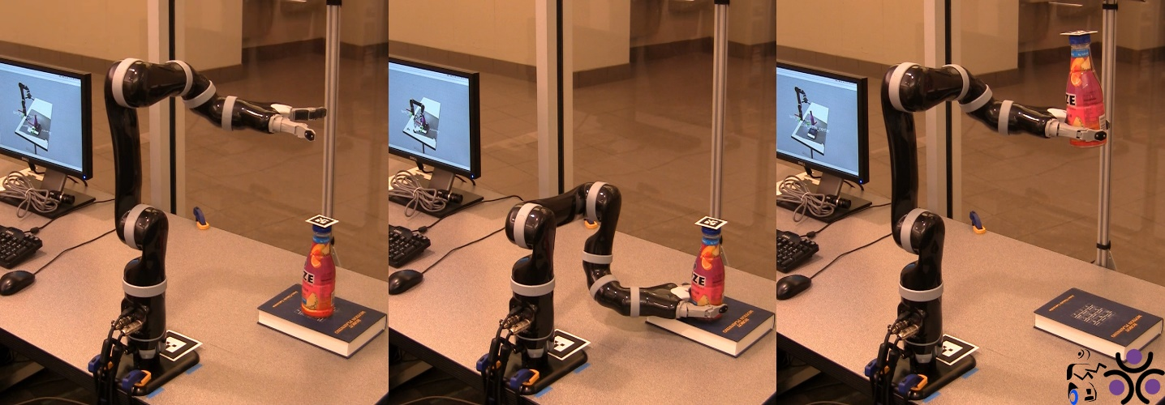

Consequently, the feeding robot is actually the product of several studies. First of all, the robot had to learn how to poke food correctly. It may sound simple, but think about how it feels to pierce the surface of a crunchy carrot, a smooth but soft grape, or a soft banana. "People are changing the way they puff food based on the shape of the food, its hardness, ease of feeding, etc.," says Gilwoo Lee, a UW computer science doctoral student working on the project. So people were brought to the lab and handed a sensor-laden fork that they grabbed a dozen foods and lifted to feed a mannequin. The researchers recorded the data to better understand micro-movements in the game.

**[2] My Spoon**

My spoon is suitable for Japanese food. It consists of a five DOF manipulator, a holder and a food tray. There are four rectangular cells in the food tray. My Spoon combines several pre-programmed actions: automatic action, semi-automatic action, and manual action. Semi-automatic process allows the user to select food. Manual operation can change the position where the food is held. The input device can be selected from: jaw joystick, reinforcement joystick and switch. The end effector of the robotic arm has a spoon and a fork that move together to perform the grasping action. During the grasping process, the gap between the spoon and fork changes so that the final effector grabs the food. The robot then moves to a predefined position in front of the user's mouth, and the fork moves backward to allow the user to eat food from the spoon.

Who can use my spoon?

My Spoon cannot be used if any of the following conditions are met:

1. Problems with chewing and / or swallowing.
2. Motor control problems such as moving your head towards the spoon, using a joystick, or pressing a button.
3. Problems maintaining an upright posture (more than 60 degrees from horizontal) for an extended period of time, even when using a belt or other mechanism to help maintain posture.
4. Problems seeing my spoon arm.
5. Problems understanding how to operate My Spoon.

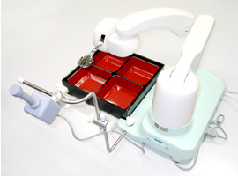

My spoon has three operating modes; manual, semi-automatic and fully automatic. Manual operation allows the user to fully control the position of the lunchbox, using a joystick:

1. Using the joystick, the compartment from the included tray which contains the desired food item was selected.
2. After the spoon reaches the compartment, the joystick to fine-tune its position near the item was used.
3. After the spoon is in place, the spoon to grasp the food was instructed by using the joystick.
4. The spoon will grasp the item and automatically approach the mouth. When the mouth comes in contact with the spoon, the fork will automatically retract.

In fully automatic mode, My Spoon will automatically select a pod, grab a food item and move it to the mouth. While this is a great addition to the assistive technologies currently available for people who really need it, I admit I was also wondering how Americans, the fattest people in the world, could benefit from this technology. I'm afraid I can see this being done to a sunbed; Sports fans (and soap opera fans) just need to press one button and then keep watching the tube while their faces are automatically filled.

**[3] IEAT Robot**

IEAT Robot which is an easy-to-use assistive eating device is specially designed for people with little or no muscle strength or muscle function and people with involuntary muscle contractions. Comes with an application to edit personal preferences and settings. Eating or feeding yourself with the IEAT Robot increases your independence level and allows you to eat out. We designed and developed the IEAT Robot to be a personal food assistant. With IEAT Robot, you are in control. The electric plate rotating unit lets you choose which part of the plate you want to grab a spoon from, so you can eat it completely independently. Specially designed spoons and plates help mimic the possibility of spillage. You decide what your next spoon will be, how fast you eat it, and you can adjust almost any setting such as speed, dwell time, automatic / semi-automatic mode.

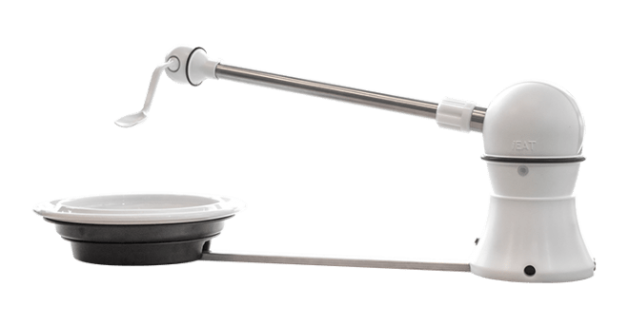

***How does it work***

IEAT Robot performs several movements sequentially, either automatic or semi-automatic. When starting the IEAT Robot, you determine the mouth position. This is the position where the spoon should come back after removing the food from the plate. After determining the mouth position, if the iEAT is in Automatic mode, it is sufficient for the user to start the sequence. If in semi-automatic mode, the user has to initiate the next step in the sequence, which gives the user more control. When eating with iEAT in semi-automatic mode, you can also determine what the next spoonful will be. The application allows you to adjust all settings according to your personal preferences. The IEAT Robot is lightweight and has a built-in battery so you can take it with you when you go to eat.

The IEAT Robot is more compact and has fewer loose parts. We have integrated a rechargeable battery, so the iEAT can be used for a few days without recharging. The dome of the IEAT Robot has an LED display that increases the visibility of visual feedback by iEAT. Control implementation has been simplified. For example: settings can now be adjusted via sliders.

**[4] The Winsford Feeder**

Winsford feeder is a mechanical self-feeding system. It uses a mechanical pusher to fill a spoon and a swing arm to lift the spoon into the user's mouth at a predetermined position. The plate is rotated to place more food in front of the pusher. The user can choose between two input devices: a jaw switch and a rocker switch. Neater Eater (Neater Solutions) has two versions: manual action type and automatic action type system. Neater Eater consists of two DOF arms and a plate. Two types of food can be found in one plate. The manual type can be used to suppress the tremors of a user's upper limbs while eating.

Winsford Feeder is a height adjustable, powerful feeder designed to allow individuals with quadriplegia or other upper limb disabilities to feed themselves independently with soup or any solid food that can be cut into small enough pieces. Height adjustment is performed using the large button on the device. The unit includes a carrying case, a Corella meal-sized plate, a soup / cereal bowl, pusher, jaw switch, cup holder, turntable, rack, Snap-On wrench and drip tray. To eat from the dinner plate, the user pushes the knob to the left, the food on the spoon and brings the food to his mouth. Repeating this process returns the spoon to the plate. Pushing the knob to the right rotates the plate to move the dinner spoon in front of the pusher to load.

**[5] Obi Feeding Robot**

The Obi robot helps the disabled eat in their environment - an important, albeit small task that preserves their dignity, preferring to get help from a robot rather than be fed by another human. Robots are also developed to literally reduce the burden of healthcare professionals.

One of the biggest concerns for people with MS, people with disabilities and other diseases is that they cannot eat alone. Thanks to technology, it makes those who do not die, and problems get solutions. Obi is a robot that is fully FDA compliant. A robotic arm attached to four food containers can feed people. The robotic arm can learn new directions in seconds. Obi can possibly learn about possible collisions, collision with learning. Again, there is nothing other than harming the person to whom he eats. With an easy setup and iconic design, Obi can eat four different meals at the same time.

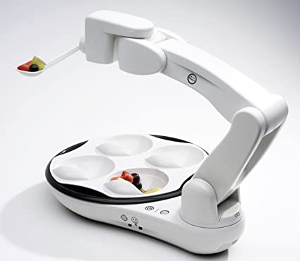

Effective food capture, smooth moves, hand guided teach mode, personable character, simple and intuitive diner controls can be counted among its features.

**[6] Handy1**

Handy1 is an assistant robot for daily activities such as eating, drinking, washing, shaving, teeth cleaning and making up. Handy1 consists of five DOF (degrees of freedom) robots, a gripper and a tray unit. The main function of Handy1 is to aid eating. Handy1 allows the user to select food from anywhere on the tray. A glass is attached to allow users to drink water with their meals. The walled pillars of a dinner plate serve an important purpose: Food can be transferred to the plate without the need to mix the food items with any result. The need for a system like Handy 1 is increasing day by day, the changing age structure in Europe means that more people with special needs are cared for by less healthy people. Handy 1's simplicity and multi-functionality has increased its interest in all disabled groups as well as their caregivers. The system provides people with special needs greater autonomy and independence, thus increasing self-confidence, boosting morale and increasing their chances of integration into a 'normal' environment.

It is a designed rehabilitation robot to enable people with severe disabilities to regain independence / regain in important daily life activities such as eating, drinking, washing, shaving, tooth cleaning and makeup. Changing age structures result in an increase in the number of people with special needs, placing even greater demands on the care worker community. Dependence on nursing staff can have a significant impact on an individual's well-being and quality of life, especially in public institutions where the volume determines the level of personal attention. The introduction of systems such as Handy 1 will encourage greater personal activity and lead to a higher level of independence. The impact of Handy 1 on the community of caregivers will significantly help reduce the amount of stress that is present when caregivers help people with disabilities one-on-one.

**[7] Neater Eater**

There are two versions of Neater Eater: manual action type and automatic action type system. Neater Eater consists of two DOF arms and a plate. Two types of food can be found in one plate. The manual type can be used to suppress the tremors of a user's upper limbs while eating.

Neater Eaters is easy to use and packed with features and accessories that can be adapted for people with a wide variety of abilities and needs.

1. It increases independence.
2. It promotes social interaction.
3. It helps protect dignity.
4. Improves posture and mouth control.
5. It stimulates interest in meal and meal times to improve nutrition.
6. It helps caregivers.

This equipment can be used by cerebral palsy, multiple sclerosis, motor neuron disease, head injuries, spine injuries, rheumatoid arthritis, muscular dystrophies, limb amputations, ataxia, stroke, Parkinson's disease, learning difficulties and many others.

Features of the device can be ordered like plate rotates in both directions on the stand, wiping function removes drips from the base of the spoon before serving it to the eater, food in the spoon may be emptied if you change your mind about the next mouthful, quick and easy to adjust the position of the spoon to match the change in the user's mouth position, catered for a wide variety of different mouth positions, base is magnetic and holds the controller in place, the unit recognizes when the spoon is removed; Choosing the fork allows food to be selected with a blade action, different plate sizes can be detected and adjusted and for customers who cannot use the touch screen, the robotic cleaner can be programmed to operate with one, two or three light touch switches according to individual skills.

**[8] Meal Buddy**

Meal Buddy (Sammons Preston) has three DOF robotic arms and three bowls that can be mounted on a board using magnets. After the system grabs the food, the robotic arm grabs the excess food from the spoon with the stick on the bowls. Meal Buddy combines robotic technology and personal features to create a truly original electronic assist feeder. Like the perfect waiter, Meal Buddy addresses individual needs, making meals easier and more enjoyable. Actually, service might be her middle name! This innovative feeder also eases the workload of caregivers as they are free for other tasks. Although Meal Buddy is full of features, it is ready to use right out of the box; just follow the one-page Quick Start card. Electronic design speed allows you to customize the spoon position, bowl selection, and more. Each of the supplied bowls has a wiper bar to clean excess food and drips from the spoon. Includes robotic arm, white base, three bowls, spoon, and button switch 2-1 / 2 "diameter and carrying case. The bowls and base are dishwasher safe.

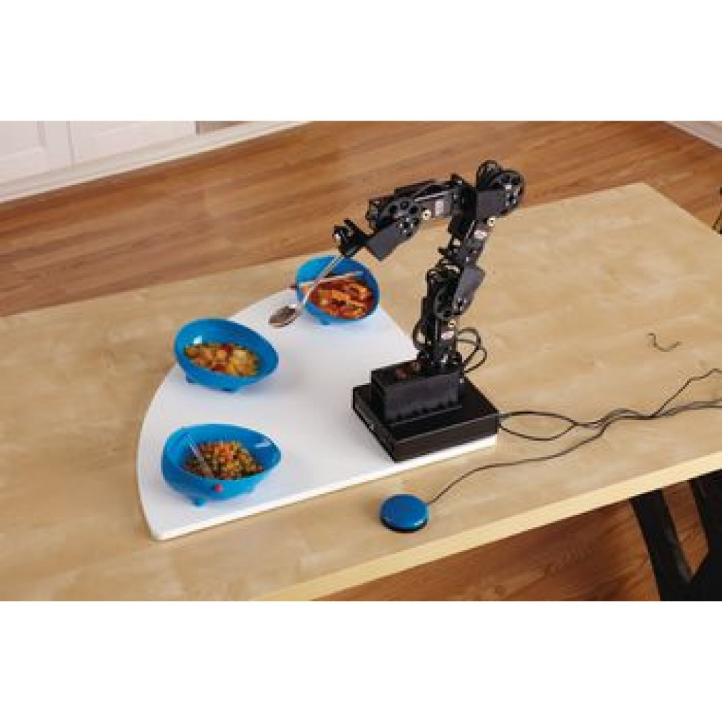

One-touch, push-button operation, stops at any time the restaurant desires, and includes an optional sip n puff option, adjustable feeding cycles (sequential, random and user selection), erase mode to prevent drips and programmable nozzle position for perfect fit, activation is easy with a one-page quick start card and adjustable speed settings and food quantities, comes with an attractive carrying case for easy portability and optional battery and charger for use anywhere.

**[9] The Mealtime Partner Dining System (Mealtime Partners)**

Mealtime Common Meal System (Mealtime Partners) is placed in front of the user's mouth. Three bowls can rotate in front of the mouth. The spoon picks up the food and then moves a short distance to the predetermined position of the mouth. This system reduces the possibility of the spoon slipping on the wet food as the underside of the spoon is wiped off after the spoon is removed. Due to the way the system is positioned, the user does not need to lean towards the feeder. Some systems have a beverage straw next to the spoon. Other systems are designed for multiple users.

The Meal Time Joint Utility Meal Device (often referred to as Common by users) is a robotic feeding device that serves a wide variety of widely accepted table foods normally eaten with a spoon or fork. Peas, mashed potatoes, cereal, pudding, fruit cocktail and other similar foods are all served "hands-free" with Partner. Larger foods like meats, pizza, cookies, and salads are also easily served after being cut into bite-sized pieces. It can serve a tissue-controlled diet equally well. The ability to self-select foods and the capacity to determine their own eating rate could potentially improve some of the risks of aspiration and choking, which are often associated with feeding, as well as some malnutrition and / or stomach problems occurs for people fed. (Mealtime Partner is referred to as an assistive eating device because the term feeding device or feeder is typically associated with feeding animals, and giving dignity to individuals with disabilities who cannot feed themselves is an important part of the assistive technology offering for independent eating.)

**Benefits of the** **Mealtime Partner Dining System:**

1. Users will enjoy being independent while feeding themselves
2. Choose their own food and control the speed they eat
3. When the user can choose the speed of eating, the risk of aspiration and reflux is reduce
4. Reduces the potential of "learned addiction"
5. Non-feeding provides increased capacity for social interaction during meals (Partner's quiet work and offset positioning enable typical conversation during meals)
6. Caregivers will enjoy the reduced effort required to provide meals and snacks

**Advantages of using the device:**

1. Easy to use (no complicated coordination of key activation by light or sounds)
2. Very safe to use (uses an unbreakable plastic spoon and very low spoon extension force)
3. Multiple / versatile mounting and positioning methods allow any user capable of chewing and swallowing normally
4. Quick and easy to learn how to set up and use (comes with an instructional video on DVD)
5. Partner is very patient - never rushes the user (spoon touch sensor notifies the device that the user has finished taking food from the spoon)
6. Very reliable operation (will last for years)
7. For children, versatile positioning and adjustable timing allow the Partner to grow with the child into adulthood
8. Technical support before and after purchase

**[10] Remote Controlled Service Robots**

Remote control, monitoring, programming and even servicing of industrial robots aim to be standard solutions in the contemporary industry. Remote methods and applications are comfortable and safe answers to industrial challenges that provide additional functionality and increase efficiency and productivity. Service robots are "the ability to perform the intended tasks based on the current situation and perception without human intervention". For service robots, this ranges from partial autonomy, including human-robot interaction, to full autonomy without active human-robot intervention. Professional service robots are different from industrial robots. They are completely different in form and function. While industrial robots are used in the manufacturing industry, professional service robots automate trivial, dangerous, time-consuming or repetitive tasks, leaving human workers to perform more intellectual functions.

Medical robots are professional service robots used in hospital settings and outside to improve the level of patient care. These robots reduce the workload of healthcare professionals, allowing them to spend more time looking directly at patients. Medical service robots include telepresence robots for remote care, disinfectant robots to reduce hospital-transmitted infections, robots that can take blood accurately and efficiently, and robotic exoskeletons that provide external support and muscle training for rehabilitation. Mobile medical robots are used for the delivery of medication and other sensitive materials in a hospital. There are chatbots that identify patients via text messages using artificial intelligence. Scientific service robotics samples perform repetitive tasks commonly found in research, such as data collection, analysis, and hypothesis generation. Autonomous scientific service robots are used to perform tasks that may or may rarely be performed by humans. Examples are deep sea exploration and space exploration service robots.

**[11] Assistive Robots**

According to the VDL’s definition, “An assistive robot performs a physical task for the well-being of a person with a disability. The task is embedded in the context of normal human activities of daily living (ADLs) and would otherwise have to be performed by an attendant. The person with the disability controls the functioning of the robot.” People have always sought ways to do their jobs easier. That's why manufacturers have offered a variety of devices to help us in our daily life over the years. Robot assistants are designed to carry out housework, social life and work-related tasks, and they are constantly learning as well as being created to "love" these boring jobs that we don't like. In certain jobs, they can achieve much better results than we can.

Robotic assistive devices are increasingly being used to improve the independence and quality of life of people with disabilities. Various devices such as robotic feeders, smart electric wheelchairs, stand-alone mobile robots and socially assistive robots are becoming more clinically relevant. It is increasingly important for the rehabilitator to be aware of existing systems and ongoing research efforts. In the last few decades, many assistive robots have been developed for elderly and disabled people. However, few became commercially available. The root cause of the problem is that the cost-benefit ratio and their risk-benefit ratio are not good or known. Their assessment should be made in light of the effects of assistive technologies on users' entire lives, both in the short and long term. Robotic assistive devices are increasingly being used to improve the independence and quality of life of people with disabilities. Various devices such as robotic feeders, smart electric wheelchairs, stand-alone mobile robots and socially assistive robots are becoming more clinically relevant. It is increasingly important for the rehabilitator to be aware of existing systems and ongoing research efforts.

Assistive robots are devices that help elderly and disabled people to perform their daily activities without the help of anyone else. They help them return to normal life by supporting basic needs such as bathing, dressing, eating, taking medicine, communicating, playing, exercising, reading, relaxing and socializing. Assistant robots are mostly used for weak elderly people, amputees and spinal cord injuries, cerebral palsy, rheumatoid arthritis, paralysis, transient disorder, etc. It benefits others suffering from such ailments. Control to redefine what they want their body and abilities to look like.

**[12] MANUS Wheelchair Robot**

MANUS is a wheelchair mounted general purpose manipulator and is currently used in homes with more than 100 people in the Netherlands, France and other countries. MANUS has six main degrees of freedom, excluding the holder. Motors are placed on the base to keep the arm slim. The resulting low arm mass provides a reduced impulse in the event of a collision. A complex system of toothed belts, hollow shafts, and gear wheels drives the end effector. MANUS is equipped with a two-finger holder. Fingers have passive tilt mechanisms that provide a three-point gripping action for most objects. A modular control system is used to direct the manipulator to the desired position. For this, a simple but effective user interface has been developed that can be configured by the therapist as well as the end user. MANUS was the world's first assistive robotic arm.

**[13] Robotic Surgery or Robot-Assisted Surgery**

We can define robotic surgery or robot-assisted surgery as performing some operations through small holes using the "da Vinci" system. After laparoscopic surgery following classical surgeries, it provides numerous convenience to both patients and surgeons as a new step in minimally invasive surgery. With the help of instruments modeled on the wrist, intuitive motion control, high-resolution three-dimensional image features, the surgeon allows the surgeon to overcome the limitations of traditional open or closed surgery technologies, and to perform more complex procedures with closed surgery. Thanks to this method, the surgeon sitting on the console can clearly see the three-dimensional view of the operation area.

*Areas which are robotic surgery used in general surgery*

* Adrenal gland
* Obesity surgeries
* Colorectal (large intestine) surgery

The instruments on the arms of the robotic surgery system can be defined as small instruments with 7-stage free movement. The tips of these tools can rotate 540 degrees around their own axis thanks to the system called "end wrist" (imagine that your wrist rotates around itself about 2 times) and can imitate the movements of the wrist of the human hand. Surgical intervention can be performed in very narrow and deep areas with these tools. With its "tremor scaling" feature, the robotic surgery system does not transmit the surgeon's possible hand tremors during the operation to the instruments. In addition, these devices do not work outside the surgeon's control.

The images obtained with the robotic surgery system allow the relevant area to be intervened with a three-dimensional image and a sense of depth. Since the camera is under the control of the surgeon, magnified images of anatomical structures in deep and narrow areas can be obtained. Injuries that may occur during surgery can be minimized. The instruments on the arms of robotic surgery can rotate 180 degrees in all directions, similar to the human wrist. These instruments can also be twisted far beyond the mobility of the human wrist, as well as rotated 540 degrees. In this way, it can reach many points of the body (especially in narrow and small areas) and perform surgical interventions. Human hand can shake more or less physiologically; however, the sensitive movement ability of robotic surgery's arms can eliminate this tremor. In this way, human errors can be reduced in the interventions in risky areas.

During surgery, surgeons are usually standing, which can make it difficult to stand due to fatigue in long surgical interventions. In robotic surgery, the surgeon manages the operation from the console opposite him while sitting. Meanwhile, the concentration of the surgeon increases while the stress due to physical fatigue decreases. Having a lot of fatty tissue in obese patients can make surgeries difficult. Robotic surgery system; It is widely used in many fields of medicine, from urology to cardiology, from gynecology to general surgery, and many different operations can be performed even in morbidly obese patients.

**[14] Da Vinci**

The da Vinci system, prototype of which was revealed in 1997, was first tested with robotic cholecystectomy (gallbladder surgery). In 2000, with the approval of the American Food and Drug Administration (FDA), it was first used in cardiovascular surgery, then widely in urology, general surgery and gynecology.

Da Vinci Robotic Surgery or also known as robotics, medicine is the most advanced technology reaches of surgery in the world and especially in Turkey, especially in urology, including major centers in the US, gynecology, general surgery, ENT, thoracic surgery, is used in heart surgery. The da Vinci robot does only what the surgeon wants, so it's not possible to operate on his own. The biggest advantages of the surgical robot, which is used in many areas, especially in urology, general surgery and gynecology, is to increase the success rate of the operation and to reduce the bleeding rate. Operations performed with the famous operating robot "Da Vinci" of Intuitive, the first company to develop the surgical robot, are defined as "robot assisted laparoscopy surgery". In other words, it is a newly developed third surgical method besides "open surgery" and "laparoscopic surgery" that we have heard until today.

During the surgery to be performed with the da Vinci robot; the surgeon sits on a console slightly ahead of the patient's table where he can command the surgery. On this console, a three-dimensional view of the operating field is taken and the surgeon can move the robot's arms with the sensors attached to his fingers. The robot has 4 arms. These have the ability to rotate 540 degrees and move in 6 directions. One of the arms is actually a camera. It projects a high resolution 3D image on the monitor by magnifying it 10 times. Clear images can be obtained at larger magnification by getting very close to the organ to be operated. With these images, the surgeon performs a difficult and delicate surgery by activating the other arms of the robot, which can act like a surgeon's hand. In addition, since it is much smaller than the human hand, it can enter places where the surgeon's hand cannot reach during operations. Thus, it provides many advantages to both the patient and the surgeon.

*Important advantages of Da Vinci Robotic Surgery*

* The success rate increases in difficult laparoscopic operations: Thanks to the three-dimensional camera, the most difficult to observe areas can be seen easily. In addition, the robot's arms have the ability to rotate 540 degrees and move in 6 directions. Moreover, he can do the same hand gestures. Thus, even the most difficult surgeries can be performed easily.
* Bleeding rate decreases: Thanks to three-dimensional high-resolution cameras that can enlarge the operation area, the bleeding areas can be seen clearly and blood transfusions are not needed in most patients because of very little blood loss.
* The patient is suffering less pain: Since the difficult operations that can be performed with large incisions are performed with mini incisions, patients feel less pain after surgery compared to the open operation.
* There are no large surgical scars on the skin: Since the procedures are performed through 3-4 holes of 8 millimeters, there is no aesthetically disturbing scar on the skin.
* The length of stay in the hospital is shortened: Thanks to the small surgical incision and less blood loss, patients can be discharged within 1-2 days even after the most complicated surgeries.
* It enables a rapid return to work and social life: Minimal damage occurs in the operation areas. In this way, it is much easier and faster for the patient to stand up and regain normal physical activities.
* Chemotherapy can be started immediately: In operations performed with large incisions, the wound is expected to heal if chemotherapy is needed. On the contrary, since robotic laparoscopic surgery is performed with mini incisions, wound healing is not a problem and chemotherapy can be started in a short time.

**[15] Biomechatronic System**

Biomechatronic systems use biological feedback elements as well as conventional feedback elements. The processes in the design, production and control of these systems need to be improved. For this purpose, methods developed especially in the sense of control should be fully integrated and compatible with mechanisms and equipment. Especially with the increasing world population, the biomechatronic systems to be developed for the effective treatment of people with disorders or deficiencies in body functions anytime, anywhere and to be able to live as an individual without being dependent on others are extremely meaningful. Neuro prostheses, artificial organs, orthoses and prostheses, biological feedback controlled rehabilitation robots can be counted among the application areas of biomechatronics. The purpose of biomechatronic systems is to support limb movements, strengthen limbs, make problematic body functions functional, or perform functions by replacing the units that perform these functions.

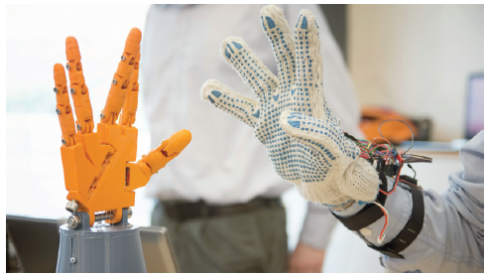

Biomechatronics, one of the subfields of mechatronics, is an interdisciplinary branch related to the mechanical, electronics, computer and biological sciences. The purpose of biomechatronic systems is to support and strengthen the human body, to make problematic body functions functional or to fulfill the functions of these functions. A biomechatronic system consists of a mechanism, a controller (electronic hardware and software) developed to control this mechanism, an actuator for driving the mechanism, and biological and mechanical sensors. Biological feedbacks (muscle signal, brain signal, blood pressure, etc.) are detected by biological sensors, while mechanical feedback (force, position, speed) is detected by mechanical sensors. The controller carries out communication between the mechanism and the human. Actuators enable the mechanism to generate force or motion.

Biomechatronics research has focused especially on supporting or restoring human mobility, artificial organs and neuro devices. For an effective biomechatronic system design, the neural and physiological structure of the human body should be well understood.

In addition, individual systems and useful interface designs can be counted among the indispensable elements of biomechatronic systems. Rehabilitation robots (orthosis, prosthesis, smart therapeutic device designs), smart insulin pumps, neuroprostheses can be given as examples of biomechatronic systems.

**[16] Biomedical Equipment**

**1. Medical Imaging Systems**

**Name: Magnetic Resonance Imaging (MR) Device**

Description: An imaging system that enables advanced image creation using a large magnet, radio waves, and antenna. It does not contain ionizing radiation. There is no known risk for patients if applied correctly.

Function: Examines tissues, organs and skeletal system

Provides high resolution image results

Allows evaluation of soft tissue and nervous system

**Name: Computed Tomography Device**

Definition: It is an imaging method that uses X-rays to create detailed pictures or scans of areas inside the body. It creates cross-sectional images of bone, vein and soft tissues by combining X-ray images taken from different angles. 3-dimensional images are obtained in sections.

Function: Takes a cross-sectional 3-dimensional view from the relevant region.

Stores images as electronic data files

**Name: Digital Angiography Device**

Definition: Stenosis in the blood vessels in the brain, abdomen, skin, arms and legs, namely the whole body, aneurysm (balloon-shaped enlargements in the vessel), malformation, fistula, etc. It is used to detect diseases that occur.

Function: Displays vessels thanks to the contrast agent delivered

CT combines with MR images

**Name: Digital X-Ray Device (with ceiling stand / floor standing / mobile)**

Definition: A device that enables the structures in the body, especially bones, to be viewed by X-rays. It is used to help diagnose the disease. The image is digitally saved.

Function: creates pictures of the interior of the body.

Static or dynamic imaging can be done depending on the device type.

**Name: Gamma Camera**

Definition: It is a camera system that enables imaging by recording the gamma rays coming from the radioactive material in the drugs without producing radiation, using imaging drugs to show the working state, anatomy, physiology and pathology of internal organs. The resulting functional images are saved.

Function: If there is a disease, its level is determined by imaging.

Diseases and physiological events are displayed at the molecular level

Provides detailed information about the structure and functions of organs

**Name: Bone Densitometry (DEXA) Device**

Definition: It is a diagnostic device that detects bone resorption by measuring and evaluating bone mineral density. Bone density measurement is provided using low-dose X-rays and computers.

Function: Measures bone density / bone measurement (thickness, fullness, strength).

**Name: Color Doppler Echocardiography Device**

Definition: It is a device that enables the examination of the internal structure and functions of the heart through sound waves. It is made with a device that enables the transmission of sound waves. By applying the transducer to different parts of the chest wall, the walls and lids of the heart are examined in different positions.

Function: Provides information about the structure and movements of the heart

The pressures of the heart cavities and the degrees of valvular insufficiency are determined.

**Name: Color Doppler Ultrasonography**

Definition: Ultrasonography device images the organs within the body using high frequency sound waves. It does not contain radiation, although it is generally used for pregnancy, it is also preferred for the follow-up of some diseases. Unlike normal ultrasound, Doppler also measures blood flow.

Function: Blood flow problems that can be caused by clots in the veins or narrowing and blockages in the arteries are detected.

Displays the baby in pregnant individuals and evaluates the baby's blood flow

**Name: Mammography Device**

Definition: It is a radiological diagnostic device that allows a detailed examination of female breast tissue using low doses of radiation. It is applied for early diagnosis of breast cancer.

Function: Displays breast tissue and measures density.

Breast cancer screening test

**2. Operating Room and Respiratory Devices**

**Name: Anesthesia Device**

Definition: It is a device that provides the required oxygen and other medical gases to be delivered in a controlled and required intensity for the patient and at the same time provides close monitoring of vital functions through a monitor.

Function: It gives the patient artificial respiration.

It closely monitors and shows the vital functions of the patient.

Automatically stores information about the patient in the computer environment.

**Name: Operating Microscope**

Definition: Surgical applications that are too small to be performed with the naked eye are performed with the help of an operating microscope (magnification of fifty times greater) Called as microsurgery the operation microscope consists of 3 parts: the optical system, the carrier stabilizer system and the lighting system.

Function: Enlarges and brightens the surgical field

Provides a detailed view of very thin vascular tissues such as nerves

Provides observation and recording to others during surgery

**Name: Heart Lung Pump Device**

Description: The heart-lung machine takes over the functions of the heart and lungs by sending blood that is free of carbon dioxide and oxygenated to the other organs of the body, and allows the heart and lung to be stopped during surgery.

Function: Adds oxygen to the blood from the veins

Delivers oxygenated blood to the patient's arterial system at a rate appropriate to the working speed of the heart.

It keeps the patient's blood volume and blood temperature within certain limits and maintains the chemical balance of the blood.

**Name: Ventilator Device**

Definition: It is a device that provides direct oxygen delivery to the lungs through a tube attached to the mouth when respiratory support is needed. It causes mechanical ventilation by moving air in and out of the lungs or exhales if the patient is breathing inadequately.

Function: They provide breathing in people who have lost the ability to breathe on their own.

It carries oxygen to the lungs; removes carbon dioxide from the body

**Name: Defibrillator Device**

Definition: A device that delivers high-value flow for a short time to the heart to regain its normal rhythm when a heart has entered fibrillation (the condition where the heart cannot pump blood). It can be briefly defined as an electro shock device.

Function: Displays the heart's electrical signals

It restores a normal cardiac rhythm by applying electrical current to the stopped or stationary heart.

**Name: Electrocautery Device**

Definition: It is an electric tool with a pen-like tip that uses high frequency to burn and cut biological tissues, thus making bloodless surgery. It is used in operating rooms for surgical purposes.

Function: They provide coagulation (coagulation) in the tissue, cut or destroy

**Name: Aspirator Device**

Definition: It is a vacuum device that is used in operating rooms, intensive care and emergency units, and in all surgical procedures that require aspiration, to extract liquid or particles with the help of an air pump.

Function: It attracts liquid or particles by vacuum method.

**Name: Auto Transfusion Device**

Definition: Auto transfusion is used to obtain an erythrocyte suspension to wash the blood lost as a result of bleeding during surgery and return it to the patient. It is useful for patients with rare blood group, immune reaction by transfusion and preventing infections such as AIDS and hepatitis.

Function: retrieves lost blood and re-infuses it to the patient.

**3**. **Laboratory Diagnostic Devices**

**Name: Auto analyzer Device**

Description: It is a device that automatically performs all kinds of analysis under computer control by means of microprocessors on liquids such as plasma, urine and serum in clinical biochemistry laboratories.

Function: It automatically performs sampling, dilution, filtering, mixing, heating and color determination.

**Name: Blood Count Device**

Definition: It is a measuring device that measures the amount of various cells in the blood. It makes cell count with electrical resistance change, laser beam distribution and photometric method. Count results are used in the diagnosis of the disease.

Function: Detects the numbers of various cells in the blood

**4. Biological Signal Monitoring Devices**

**Name: ECG Device**

Definition: It is a device that provides graphical recording of the electrical activity that occurs during the contraction of the heart. It is used for the diagnosis of cardiovascular diseases.

Function: The electrical activity generated by the heart is measured.

It transforms the activity of the heart into graphical shapes.

**Name: Bedside Monitor**

Definition: It is a device that monitors the current condition of the patient used in the intensive care units or wards of hospitals. Both visual and numerical information are presented on the monitor.

Function: ECG, Segment analysis, Respiratory rate, oxygen saturation, non-invasive blood pressure, invasive blood pressure, temperature information are monitored on the screen.

**Name: Pulse Oximeter Device**

Definition: It is the device that can measure and record the oxygen saturation and pulse in the blood in the easiest and fastest way. The recordings are reviewed on the device's own screen or by connecting to a computer. It uses the color of the blood to determine its oxygen content.

Function: Measures heart rate per minute and oxygen level in the blood.

**Name: EMG Device**

Definition: It is used to diagnose diseases affecting peripheral nerves, to confirm the diagnosis, to determine the severity of structural damage or dysfunction in the peripheral nerves, to monitor the disease process and to evaluate the effect of the treatment applied.

Function: Measures sensory and motor nerves separately.

Provides diagnosis and follow-up of nerve compression and injuries, waist and neck hernias, muscle and spinal cord diseases

**Name: Blood Pressure Monitor**

Description: An instrument for measuring the pressure within the veins or the blood pressure within the artery.

Function: Large blood pressure and small blood pressure are measured.

**5. Radiotherapy Systems**

**Name: External Beam Radiotherapy Device (TrueBeam)**

Definition: The device is used for the purpose of radiotherapy treatment in cancer disease by giving radiation only to the tumor with point accuracy and precision. It can reduce the treatment time from 10-30 minutes to 2 minutes

Function: It has functions such as imaging, patient positioning, motion management and dynamically synchronizing therapy.

**Name: Brachytherapy Systems**

Definition: In cancer treatment, close therapy is applied to tissues or cavities, tumor beds using radioactive sources.

Function: Application of radiation to tumor beds.

**Name: Linear Accelerator - LİNAC**

Description: It is a device used in cancer treatment and that does this by sending X-rays to the patient. According to the images taken from medical imaging devices, it is an external treatment device that applies high doses of radioactive radiation only to cancerous cells without damaging healthy tissues.

Function: Applies X-rays to the cancer cell.

**6. Other Devices**

**Name: Hemodialysis Device**

Definition: Hemodialysis device performs the process of cleansing various harmful products such as urea, creatinine, potassium, phosphorus and water accumulated in the body due to renal insufficiency from the blood with the help of a semi-permeable membrane (membrane) located outside the body.

Function: Cleans the blood outside of the body and returns it to the circulatory system.

**Name: Intra-aortic Balloon Pump**

Definition: It is the most widely used mechanical support device that provides temporary mechanical support in cases where the heart's pump function is insufficient.

Function: Increases oxygen delivery in the myocardium

Reduces left ventricular workload

Increases cardiac output

**Name: Endoscopy Device**

Definition: The device with a small illuminated camera at the end of the device is used to examine the gastrointestinal system, which includes the hollow organs (esophagus, stomach, duodenum and large intestine). It is used in diagnosis, follow-up and treatment of diseases. Special tools are added to the endoscopy device for therapeutic use.

Function: The inside of the organs is displayed and samples are taken when necessary.

**Name: Vein Viewer Device**

Definition: It is a device that helps the technical staff to intervene in the relevant vein by detecting the veins under the skin that the eye cannot see with infrared rays.

Function: Provides vein finding.